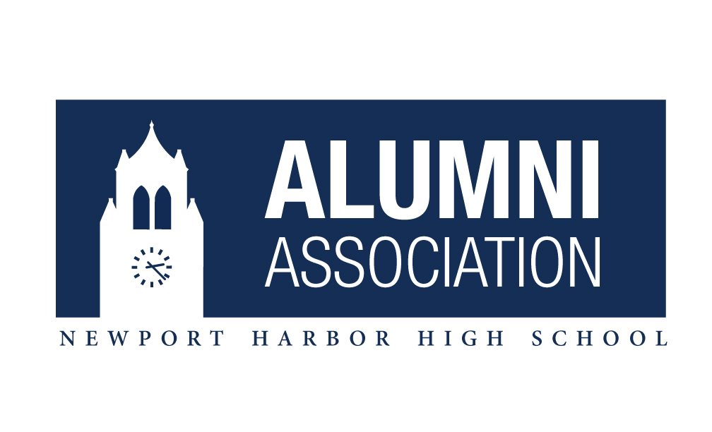

**TEN $2,000 SCHOLARSHIPS**

**NOW AVAILABLE!!!**

**The Newport Harbor Alumni Association** is excited to announce TEN $2000 scholarship opportunities for graduating Seniors who will attend a Community College, Trade, Technical, or Nursing School in the Fall of 2020. This applicant’s intentions must be to fulfill the requirements of an AA Degree, Vocational Certificate, or alike. There may be a follow up opportunity next year for a second year of support.

* To qualify for this scholarship, the following criteria must be met:

1. 2.5 GPA or better
2. Desire to attend an institution of higher education (Community College, Trade, Technical, or Nursing School) with proof of acceptance/enrollment or intention to attend
3. Show proof of community involvement through volunteer work, employment, participation in sports, etc.
4. A letter of recommendation is required
5. Able to attend the NHHS Awards Ceremony at Saint Andrews Presbyterian Church on Wednesday June 10,2020

* Winner will be decided at the sole discretion of the Newport Harbor Alumni Association Board/Selection Committee and will be based on educational goals, community involvement, and financial need, along with evaluation of an essay. All information must be true and correct.
* The 2020 Newport Harbor Alumni Association Scholarship Recipients will receive $2000, and the money will be awarded by being deposited into the education institution’s student account, co-payable to the student for direct expenses incurred for enrollment in the Fall of 2020.
* Applications available in the NHHS Counseling Office.
* All applications must be completed and returned to Mrs. Mack in the NHHS Counseling Office by 4:00pm on Friday May 8, 2020. The winner will be notified by May 29, 2020.

More Information at [www.NewportHarborAlumni.org](http://www.NewportHarborAlumni.org).